MANGAMAHU SCHOOL
Respect Excellence Responsibility Resourcefulness
Newsletter No 6 7th August 2017

Dear parents, whanau and community members,

Into term 3 already, and with the weather we have been having the fire has been blazing daily. Thank-you to Dave and Donna Matthews for popping some kindling into our woodshed – you are a great support to us at the school. Donna is now looking after our gardens and mowing the lawns, and the school is looking terrific.
Welcome, welcome, welcome – We have 3 new pupils - Zenin, L’Bron and Ry’Qah! L’Bron has been with us before and it is great to see her back again. This time she has brought with her a brother and a sister. It is fantastic to see a fuller classroom.
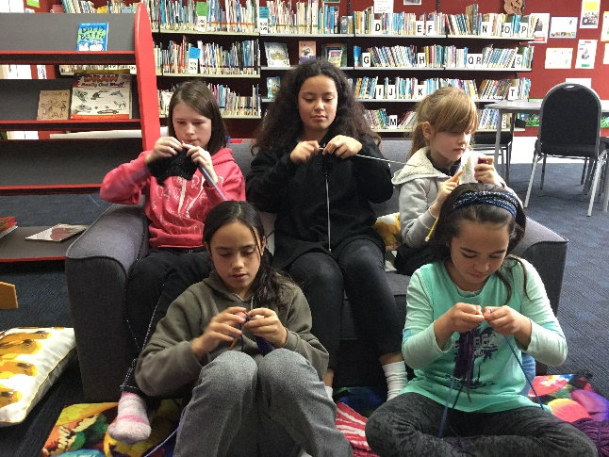

Knitting – The older students are learning to knit, so each afternoon after lunch while I read they all pull out their knitting. They all began with a practice piece and have now moved onto simple mittens. Enthusiasm and concentration is high, with many dropped stitches!

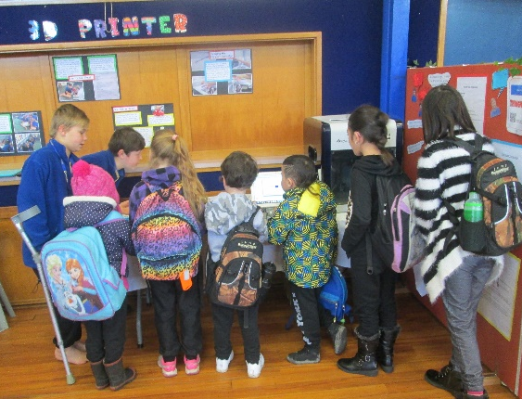

Technology Expo – At the end of last term we all went along to Carlton School to see how they use technology in the classroom, and to learn about their favourite apps. It was most worthwhile as we now know about Kahoot, Puppet Pals etc. All are keen to get on the iPads, that’s for sure.
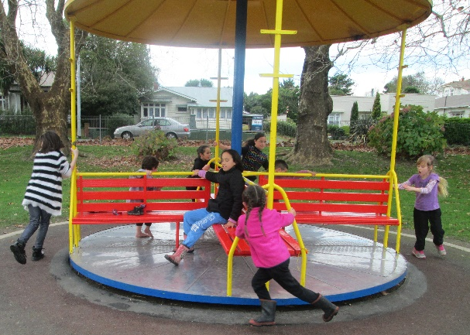

Stopping for lunch and a quick play in Kowhai Park was popular as well.
Student Awards

Ry’Qay – For trying very hard at handwriting to form letters properly.
Brooklynne – For improvement in sustained silent reading

Thank-you to PalaMountains for donating pet care nutrient packs to the school. We plan to raffle them off so be on the lookout as they are prizees worth winning.

Board of Trustees News
Next Meeting – Monday 14th August at 4.30pm.
All welcome to attend.

Upcoming Events

Country 7’s – We have been able to put together a team with Aberfeldy School as they have no girls and we have no boys, and the teams must be mixed. A round robin event at Springvale Park on Wed 9th August from 10am till 1-2pm. Parents welcome. (We have 1 spare seat in our school van if anyone is interested.)
Kids Can Fundraiser – Our school benefits greatly from Kids Can, sending us food, rain jackets, tissues etc., so we try and support them in return. Friday 11th Aug will be a crazy dress-up day with a gold coin donation. Thanks
Career Day – This is a cluster event with all year 7 & 8 attending. We are going to Massey University, going on a tour of the campus, hearing from students etc. on Wed 16th Aug.

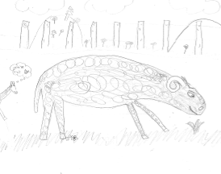
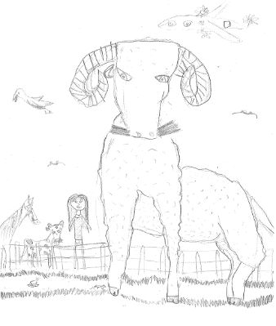
Observational Drawings of the ram in the school paddock
Brooklynne
Karma
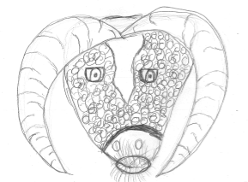

Jilyzah
Zenin

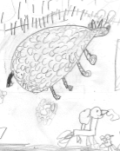

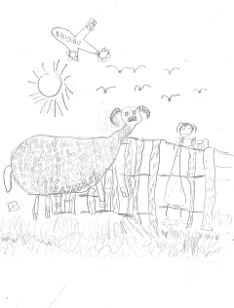

Chardel

Braxton

L’Bron

L’Bron
Dates to Remember

Every Monday from 10am to about 11.30am – Playgroup.
Everyone welcome to attend. Come along for a coffee and a chat even if you don’t have a preschooler.

.
Term 3 2017
Every Thursday out of school – technology, gymnastics & swimming
Week 3 | Wednesday 9th August | Country 7’s – Year 6, 7 & 8
 | Friday 11th August | Kids Can Fundraiser  School Assembly– 2.15pm as we have a guest speaker
Week 4 | Monday 14th August | BOT meeting at 4.30pm
 | Wednesday 16th August | Career Day at Massey University – Year 7 & 8

Rosalie Matthews
Principal

