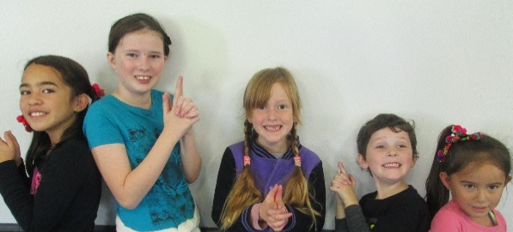
MANGAMAHU SCHOOL
Respect Excellence Responsibility Resourcefulness
Newsletter No 3 9th May 2017

Dear parents, whanau and community members,

Term 2 already, which means a return to cold mornings and lighting fires. Fantastic!!

Our big event this term is, of course, hosting the cluster cross country. The smaller our school gets, the more difficult it is to run this event each year, with many roles to fill with so few people. Thanks to those who have said they can help out again this year. Your support is greatly appreciated.
Working Bee – Thanks to those few who helped out again at the recent working all our garden waste, as he always does. Craig did a fantastic of rebuilding the front garden edge, so that garden bed is now ready to dig over and prepare for planting in the spring. Thanks again for your help and support.

Pumpkin Off – It wasn’t the best pumpkin growing season this year, so weights were not as heavy as they have been in the past. Those who joined in put in a great effort, with Alex, Kate & Elsie winning with a pumpkin weighing in at 68kg. Karma Forsyth was second and the Walford family came third. We look forward to see what happens next year.

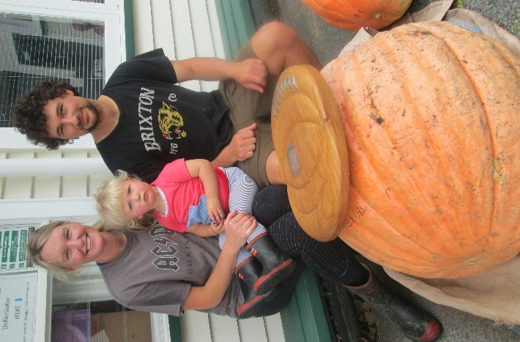

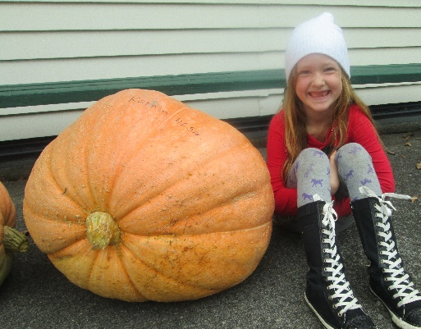
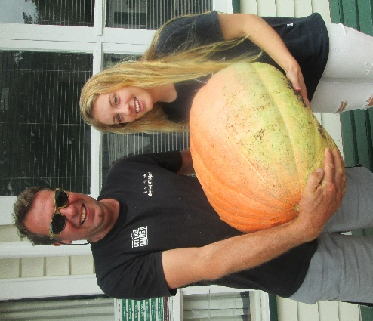

Sleepover – In the last week of Term 1 we had a sleepover at school. The senior girls planned it, so had to think about activities, food, shopping list and gear list. They did a great job and we all had a terrific night.

Finally! Two things are happening today that are exciting. It is my birthday and the school sleepover! After our lessons in town we went to Kowhai Park to play. My favourite part was the four spinning seats. You go around so fast you get dizzy. We drove back to school for the next exciting thing which was my BIRTHDAY CAKE. Mum and my family stayed for the cake and everyone sang Happy Birthday to me. I felt shy. Once we had gobbled the cake up it was time to set up the beds in the classroom. While we were waiting for dinner to cook we did craft. We made an enormous mess that we had to clean up. Whaea Rose called tea timer and we scrambled to the kitchen. We ate chicken, peas, potato and carrot. The chicken was excellent! Time for pudding. Jelly, ice-cream and fruit was served and it was eaten as fast as a cat eating cat biscuits.
By Karma

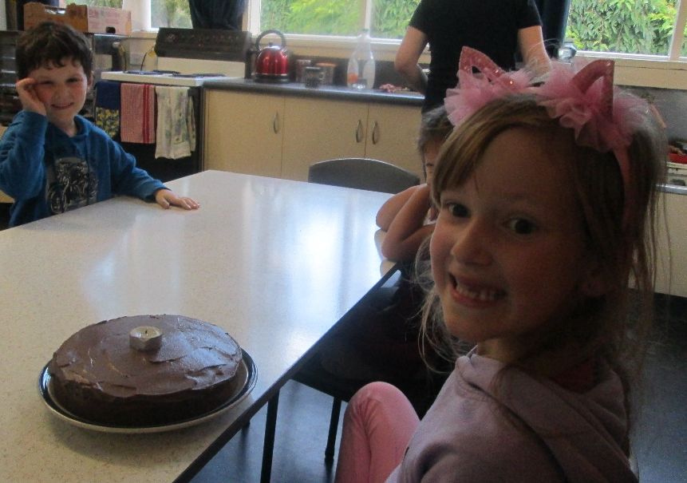

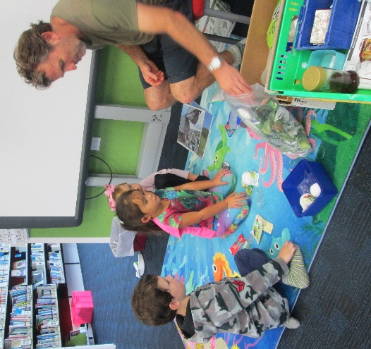
Zero Waste – Each year Hadi Gurton comes out to the school to talk about caring for the environment, reducing our waste and recycling. The 2 juniors did some shared writing after his visit.

Hadi told us not to throw our rubbish in the bin because it will go to landfill. If we can we should recycle it instead.
By Braxton and Chardel

My Blanket
When I was a young human I had a blanket, an important blanket because it controlled if I slept or not.
My special blanket was light pink and had darker coloured stars. I think I really liked pink back then. Well I don’t like it anymore!
I remember that in the mornings I would put it on my head and walk around. I used to look at the ground so I wouldn’t crash into the walls or doors. I don’t think I ever crashed.
Because I couldn’t sleep without it, Mum and Dad had “back up” bright blankets. When I lost one or Mum was washing it, they would give me a “back up”. I could never tell the difference because they looked very, very similar.
I don’t have it anymore but I will always remember it!
By Brooklynne

Student Awards
Chardel Tonihi – For making great progress in reading by completing the Early Words Programme.

Karma Forsyth – For showing a much improved attitude to learning.

Board of Trustees News
Next Meeting – Monday 22nd May at 6pm.
All welcome to attend.

.Dates to remember –
Every Monday from 10am to about 11.30am – Playgroup.
Everyone welcome to attend. Come along for a coffee and a chat even if you don’t have a preschooler.

.
 | Term 2 2017
Week 3 | Friday 19th May | Cross Country
Week 4 | Monday 22nd May | BOT meeting at 6pm
 | Friday 26th May | Postponement Date for Cross Country  OR  Assembly ay 2.30pm if no cross country

Rosalie Matthews
Principal

