MANGAMAHU SCHOOL
Respect Excellence Responsibility Resourcefulness
Newsletter No 9 26th October 2017

Dear parents, whanau and community members,

Term 4 is well and truly underway. Before we know it it will be time to do testing, write reports and have Prize Giving!
Congratulations to Zenin and Jilyzah for bravely participating at the cluster speech contest. Both spoke very well, and Zenin came third in her age group.
In the first week after the holidays I was called for jury duty, so big thanks to Tiffiney and Vanessa for keeping everything running smoothly back at school.

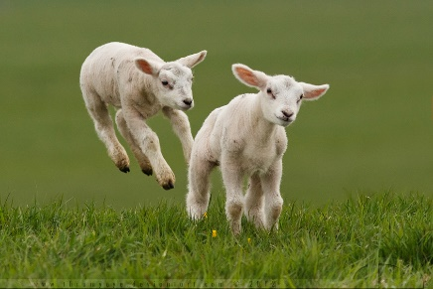
Pet Day is next Friday, 3rd November, starting at 10am.
Pre-schoolers are invited to bring their lambs and dogs along,
and there is a Chocolate Cake competition for the adults.
If you are free we would love to see you on the day.

125th Jubilee – This is coming up in 2019, and we have had one community member volunteer to help with planning and running an event. If anyone else is keen to join in please let us know.

Raffle – The school is running a raffle with some great prizes. Tickets are just $2 and it will be drawn at Prize Giving. Perhaps Pet Day would be a good day to buy a ticket?

Dress Up Clothes – Our children have really been enjoying dressing up of late, and we wondered if anyone had any clothes that they could donate to the school? All will be much appreciated.
Classroom Awards
Zenin – listening to and acting on feedback
L’Bron – bravery during speech times
Chardel – Consistently doing homework

Board of Trustees News
Next Meeting – Monday 4th December at 4.30pm.
All welcome to attend.

Our Holiday Writing

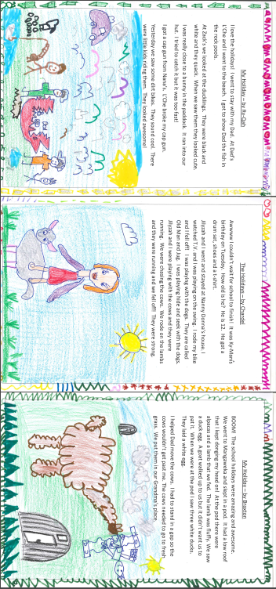

Community News

Cam and Sophie from Polson’s farm on Te Rimu Rd are offering their rotary hoe for hire (very cheap rates I believe), so call 3422854.

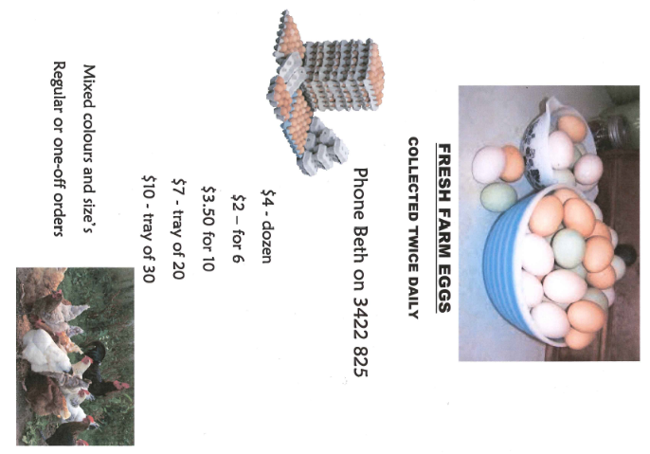

Dates to remember

Every Monday from 10am to about 11.30am – Playgroup.
Everyone welcome to attend. Come along for a coffee and a chat even if you don’t have a preschooler.

Term 4 2017
Kapa Haka each Thursday at Okoia School
Week 3 | Friday 3rd November | Pet Day at 10am
Week 4 | Monday 6th November | BOT meeting at 4.30pm
 | Friday 10th November | Ballroom Dancing Years 7 & 8
Week 5 | Monday 13th November | Cluster Athletics
 | Friday 17th November | Ballroom Dancing Years 7 & 8
Week 6 | Friday 24th November | Ballroom Dancing Years 7 & 8
Week 8 | Friday 8th December | Ballroom Dancing Years 7 & 8
Week 9 | Thursday 14th December | Prize Giving
 | Friday 15th December | Ballroom Dancing Years 7 & 8  Cluster dinner dance – Years 7 & 8
Week 10 | Monday 18th December | Last day of school!
Notices will be sent home shortly regarding ballroom dancing and athletics.

Rosalie Matthews
Principal

