MANGAMAHU SCHOOL
Respect Honesty Empathy Responsibility Perseverance
Newsletter No 10 13th December 2018

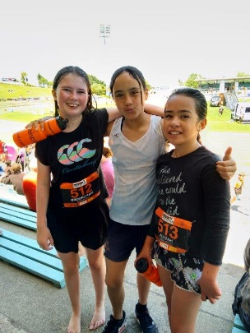
Dear parents, whanau and community members,
As always the end of the school year has been hectic, with the children involved in lots of different activities.
The seniors girls recently went to Tough Kids, where they jumped over fences, crawled through tunnels and got sprayed by water, slipping and sliding to the finish line. Not my idea of a good time, but they had heaps of fun.
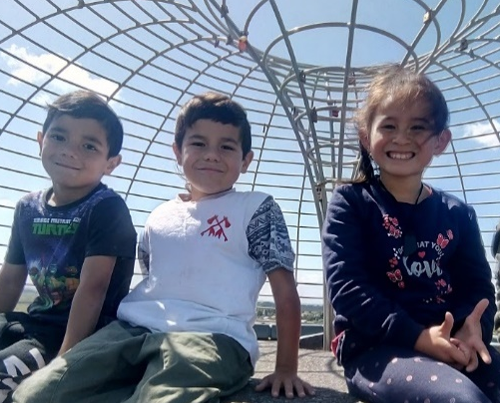
That same day the juniors had a day in town with Aberfeldy School. They went to Durie Hill Tower, the library and the new bike park. Mrs Tuka commented on their brilliant bahaviour, and how considerate they were of each other. They were such good role models, caring for each other, that the other school started to imitate this behaviour. You as parents have much to be proud of.

Animation – Sarah Thompson came into school and took an animation workshop with our students. They were really engaged, and we went onto make ‘Play Dough Movies’ using an app on the iPads called Stop Motion. We hope to show them at Prize Giving, providing we have success with our technology.

Fundraising 2018 –
- Silver Fern Rally – $500 was donated to the school for marshalling and to tie up gates. We have to apologise for not removing all those bits of plastic at the end of the day, but we had car trouble.
- 2018 Funds – Over the year we have raised $975 (+GST) by catering a car rally, a raffle at Dog Trails and the Silver Fern Rally. So far we have bought 2 glockenspiels, and plan to buy 1 more, plus another technology item called a Sphero
Swimming Pool – The pool is up and running again this year. If you are interested in purchasing a key for the summer please contact the school office on 3422807. Keys are $50, plus a $10deposit that will be returned at the end of the season when the key is returned to the office. Keys need to be purchased from the school, and we close on the 19th December so get in quick.
Board of Trustees News
Next Meeting – Tuesday 26th February at 4.30pm.
All welcome to attend.

Student Awards

Ry’Qah Mea – for improvement in maths
L’Che Mea – for enthusiasm and improvement in all areas

Dates to Remember
Term 4 2018
Week 9 | Friday 14th December | Seniors to Ballroom Dancing  Seniors – Formal dinner dance at Kaitoke School
Week 10 | Tuesday 18th December | Prize Giving at 6pm
 | Wednesday 19th December | Last day for 2018!!!  Clean up, Secret Santa, shared lunch

2019 – Wednesday 30th January – First day back
Rosalie Matthews- Principal
Tiffiney Firmin – Office Admin & Teacher Aide

