MANGAMAHU SCHOOL
Respect Honesty Empathy Responsibility Perseverance
Newsletter No 4 14th May 2019

Dear parents, whanau and community members,

Thank-you to all the families that came along on the last day of term and participated in our
Celebration of Learning. The children were very eager to share all that they had done with you. It was also a good opportunity to do Student Led Conferences so that everyone is aware of their child’s progress. With 100% attendance this was very successful. Please remember though that you are welcome to talk to us at any time about your child.

Sadly one of our students left at the beginning of term 2; Priyasha has moved back to family in town.
We will all miss her and wish her well.

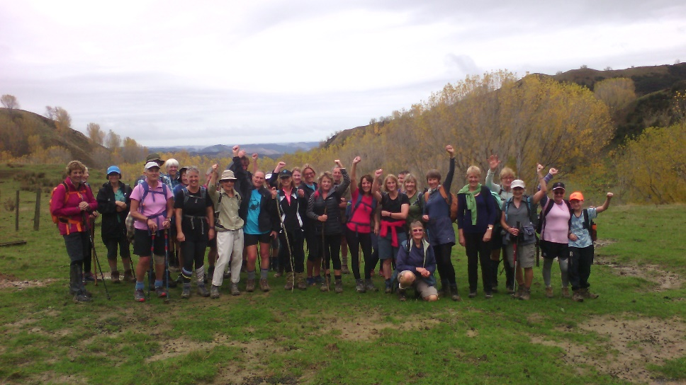
Women Walk the World –Over the holidays I was fortunate to join in on the Rural Women’s fundraising walk this year on the Harris farm. It was certainly more challenging than others in the
past as the rain the night before made the tracks very slippery, but it was thoroughly enjoyed by all. Frequent comments from the club walkers were, ‘It is not often we get to walk in places like this, around private farms.’ According to Leonora 46 of us walked 435km.
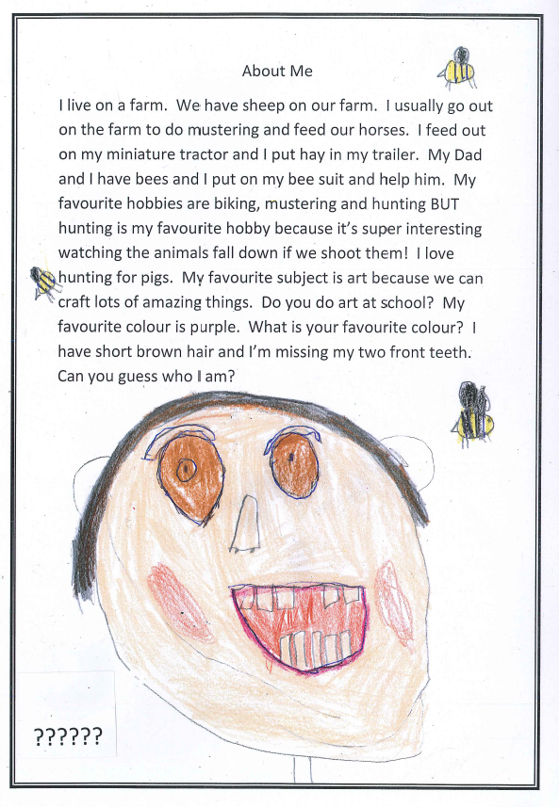
Kakatahi School – our relationship with this other small
school is developing well and we plan to meet up twice
a a term, once at each school, to foster budding friendships.
On Wednesday 15th May we will be heading to their school.
Not only is the social aspect so important, but it gives us an
O opportunity to do activities that are difficult with our
small numbers, particularly sports games.
O Our students wrote about themselves and posted these p profiles to Kakatahi School. Can you guess who they are?

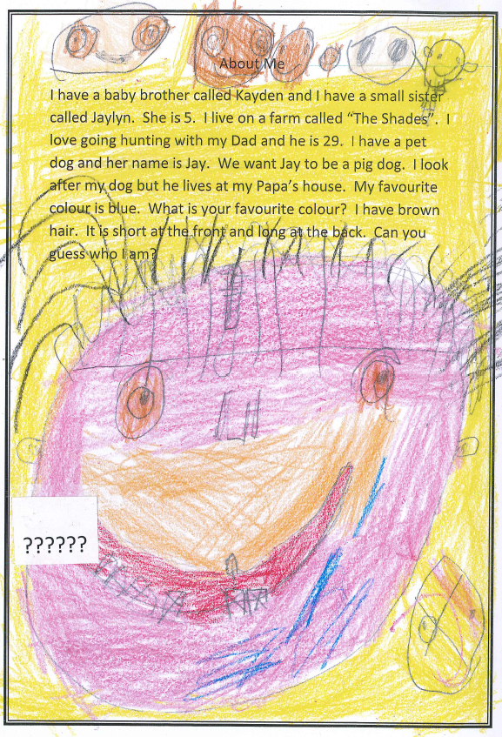

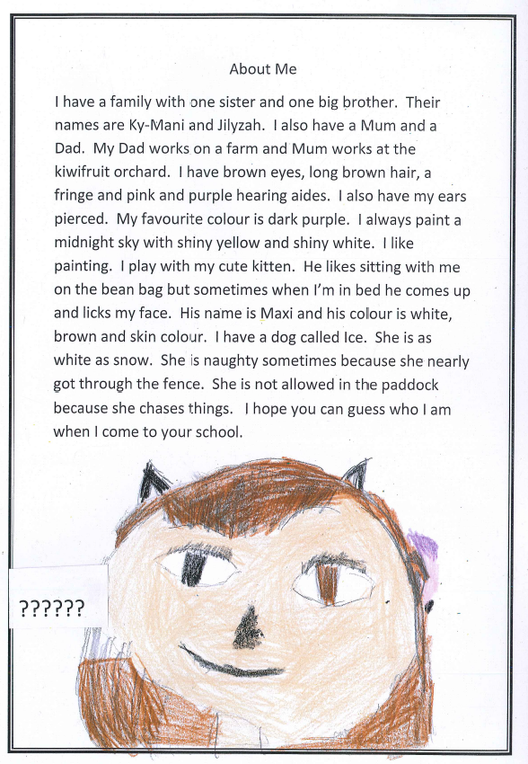

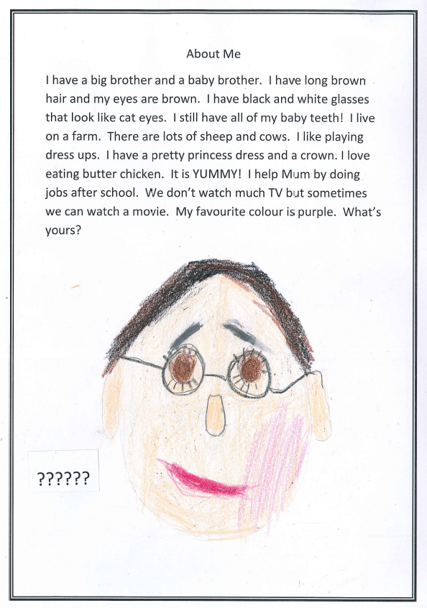

School Van for sale – 2004 HPV Mazda 7 seater 123 000km - $6000 – In excellent condition. Call 3422807
Board of Trustees News
Next Meeting – Monday 20th May at 4:30pm. All welcome to attend.

Student of the Week
Term 1 Week 10  Emily Waldron  For showing courage attending cluster activities alone. | Term 2 Week 1  Jaylyn-Jade Te Puni Olsen  For improved effort in maths and writing. | Term 2 Week 2  L’Che Mea  For great progress and effort in reading  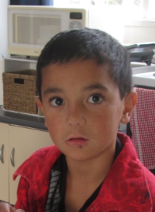
Term 2
We will continue to go to town each Thursday for swimming and tikanga.
Week 3 | Wednesday 15th May | Visit to Kakatahi School
Week 4 | Monday 20th May | BOT meeting at 4.30pm
Week 6 | Monday 3rd June | Queen’s Birthday Holiday
Week 7 | Wednesday 12th June | Matariki Glo-Show

Dates to remember – 2019

Rosalie Matthews
Principal

