MANGAMAHU SCHOOL
Respect Honesty Empathy Responsibility Perseverance
Newsletter No 9 20th November 2018

Dear parents, whanau and community members,
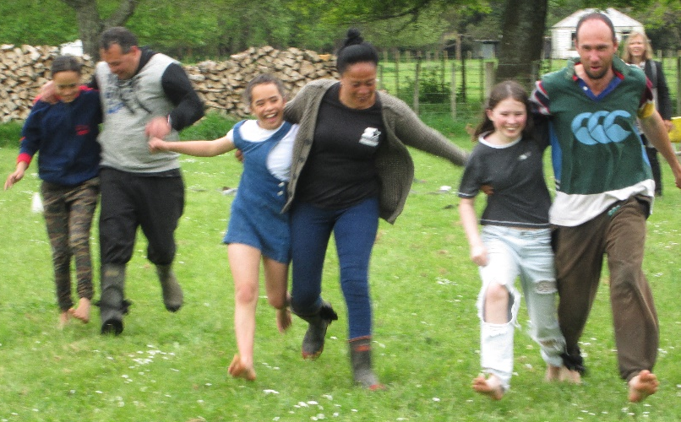
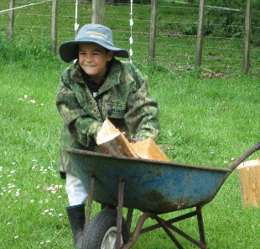
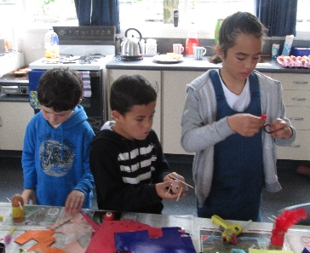
Thanks to everyone who came to our ‘No Pet - Pet Day’, joining in with the crafts and races, helping to make it successful and enjoyable for our students. In particular thanks to Tony Granger for judging and helping with the races, Jill Kellick for judging our crafts, and Blair Budge for organizing Young Farmer.
A couple of our senior students wrote haiku poems about the day-

A funny pet’s day
Because there were no pets
But filled with great games
By Jilyzah

Running with parents
With our legs tied together
Having a great day
By Brooklynne

Play Group – It is great to see our play group still going so strongly, thanks to some dedicated mums. A few months ago Kate Kellick donated some money to the school as a thank-you for hosting play group, so we in turn went and spent the money on toys for the little ones. We bought trikes, bikes and dolls in prams. (It was a challenging technology lesson for our older students assembling them, particularly when you consider the useless instructions provided!)
We were rewarded with delighted squeals from the young ones when they saw the new toys.
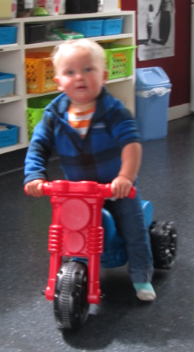
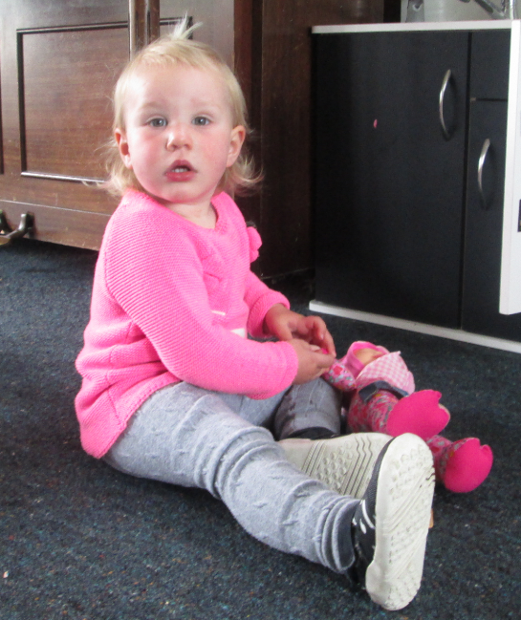

Thanks also to Bo Polson for donating stationery to the school.

Swimming Pool – Justin Tonihi has agreed to maintain our pool again this year, and hopes to have it up and running in the next few weeks. If you are interested in purchasing a key for the summer please contact the school office on 3422807. Keys are $50 and need to be returned at the end of the season.

Board of Trustees News
Next Meeting – Monday 2nd December at 4.30pm.
All welcome to attend.

Student Awards
Ry’Qah Mea – for effort made during our dance lessons
Chardel Tonihi – becoming more independent
Braxton Budge – trying hard during music lessons
Brooklynne Budge – for speaking up more during problem solving activities
Congratulations to L’Bron Sutton-Mea for winning last term’s sticker chart award.

Dates to Remember

Every Monday from 10am to about 11.30am – Playgroup
Everyone welcome to attend. Come along for a coffee and a chat even if you don’t have a preschooler.

Term 4 2018
Week 6 | Friday 23rd November | Seniors to Ballroom Dancing
Week7 | Tuesday 27th November | Silver Ferns Rally
 | Friday 30th November | Seniors to Ballroom Dancing  Assembly at 2:30pm
Week 8 | Monday 3rd December | Sarah Thompson – Animation Class  BOT meeting at 4:30pm
 | Friday 7th December | Seniors to Tough Kids
Week 9 | Friday 14th December | Seniors to Ballroom Dancing  Seniors – Formal dinner dance at Kaitoke School
Week 10 | Tuesday 18th December | Prize Giving
 | Wednesday 19th December | Last day for 2018!!!  Clean up, Secret Santa, shared lunch

2019 – Wednesday 30th January – First day back – planned already! (can you believe it?)

Rosalie Matthews- Principal
Tiffiney Firmin – Office Admin & Teacher Aide

