MANGAMAHU SCHOOL
Respect Honesty Empathy Responsibility Perseverance
Newsletter No 5 4th June 2019

Dear parents, whanau and community members,

Winter certainly hit with a vengeance on Saturday, but hope everyone was still able to enjoy the long weekend.

This term our topic has been ‘eggs’, with the children doing a range of related activities, including science experiments, researching the health benefits, readings, writing and art.
One of the art activities involved blowing an egg and then decorating it. The children really enjoyed this, and remembered to blow not suck!
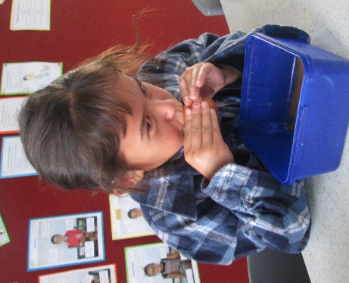
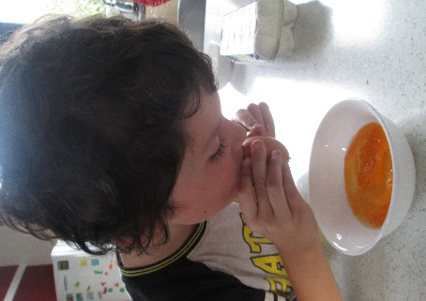
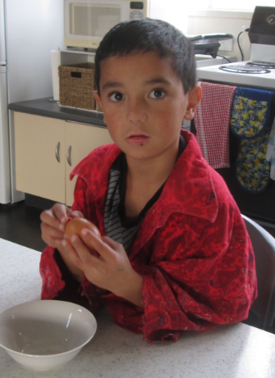

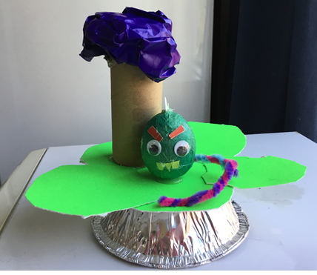
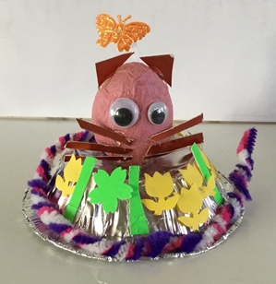
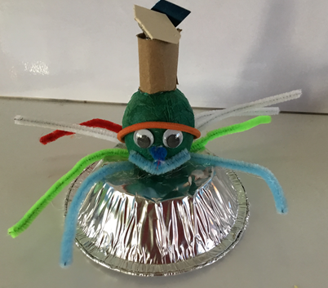

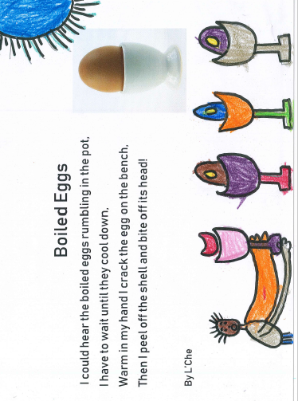
Poems about the eggs we have been cooking and eating

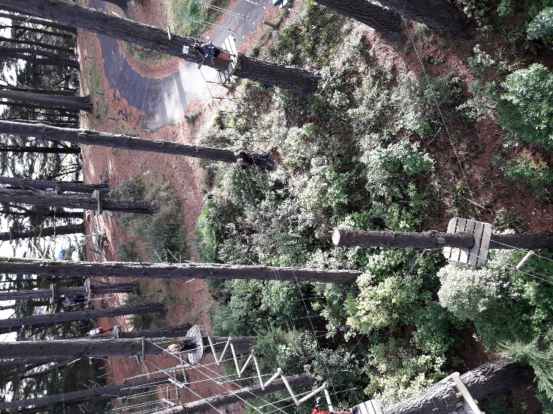
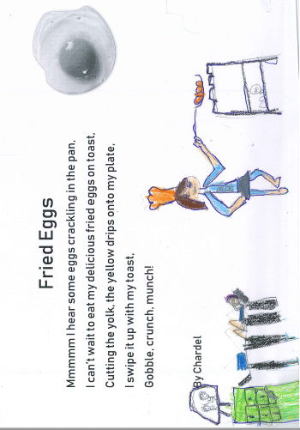
Adrenalin Forest
A few weeks ago Emily went along with the cluster schools to Adrenalin Forest as one of the physical challenges for the Tuia Challenge this year. From all accounts the day was terrific, but it certainly was challenging.

School Van for sale – 2004 HPV Mazda 7 seater 123 000km - $6000 – In excellent condition. Call 3422807

Upcoming Events
Matariki Glo-Show – We are going to see this show at the Opera House in Wanganui on Wednesday 12th June. Notice will be sent home shortly.
Board of Trustees News
Next Meeting – Monday 17th June at 4:30pm. All welcome to attend.

Kakatahi School will be visiting us again on Wednesday 19th June. This time the senior students will teach the lesson they planned last time to the juniors as part of our leadership programme.

Crazy Hair Day – just for fun, dress up too if you like, on Friday 21st June.

Whanau Day – parents, grandparents, other family members are invited to school on the last day of term to share their child’s learning. More details will follow closer to the time, but please keep this day free if you can. The children get so excited when their family can join in with these events.

Student of the Week
Term 2 Week 3  Ry’Qah Mea  For showing perseverance when faced with challenges. | Term 2 Week 4  Chardel Tonihi  For effort made when writing with Fiona. | Term 2 Week 5  Emily Waldron  For participating well in oral language.

Dates to remember – 2019

Term 2
We will continue to go to town each Thursday for swimming and tikanga.
Week 7 | Wednesday 12th June | Matariki Glo-Show
Week 8 | Monday 17th June | BOT meeting at 4.30pm
 | Wednesday 19th June | Kakatahi School visit
 | Friday 21st June | Crazy Hair Day / Dress up Day
Week 10 | Friday 5th July | Last Day of Term – Whanau Day

Rosalie Matthews
Principal

