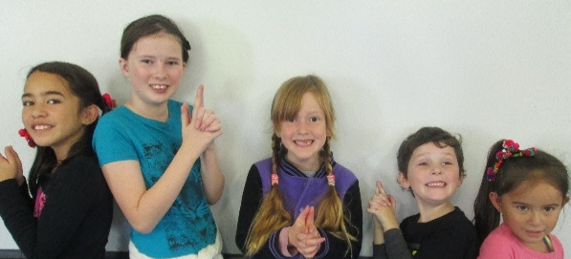
MANGAMAHU SCHOOL
Respect Excellence Responsibility Resourcefulness
Newsletter No 4 1st June 2017

Dear parents, whanau and community members,

The cross country was just not meant to be this year! We had already overcome 2 earlier crises – the rain the week before finally cleared, and then our health nurse cancelled, leaving us with no professional first aid care (luckily for us a nurse/parent at Kaitoke School was prepared to step up ) – only to have a truck overturn on the road! Although one lane was clear, and traffic could get through albeit with delays, the police told us that they couldn’t give any indication when the road would be cleared, and how long the road would be blocked for when they did. We thought it irresponsible to get lots of people on our side of the accident, then unable to get home.
Even though we cancelled in the end, we wish to thank all those who were willing to come and help on the day. Thanks also to those who had already done lots – Craig and Zac had set up the course, Dave had cut the fence, Blair had towed the toilets from town and harrowed the paddock, Ken had brought over the Horse Sports PA system, Tiff had called everyone (several times), and Duncan and I had set up the school paddock. Lots of work goes into organizing the day so that it will run smoothly. It is such a shame that it had to be cancelled at the last minute. So are we all looking forward to next year?!

There is a teacher at Okoia School who taught at Aranui School for many years, and consequently has organized many a cross country. He is going to pick it up and run an event in a few weeks for those schools that are available. We will be attending. As yet we have no details regarding times etc.
Pink Ribbon Fund Raiser – Congratulations to Karen Harris for organizing a fundraising event in the Mangamahu Hall recently. I am not sure what was raised but I hope it was lots.

Board of Trustees News
Next Meeting – Monday 19that June at 4.30pm.
All welcome to attend.

Tech Expo – There is a 2 day Tech Expo being held at Carlton School on the 30th June/1st July. I have attached the flyer if anyone is interested. We will be attending as a school as they not only have hardware on display, but are running workshops for both students and teachers. It will be a good chance to learn more about the best education apps.

Writing – In the classroom we have been trying to get the children to ‘show’ not ‘tell’ - through the use of language features and good descriptive adjectives. I think they are progressing at an amazing rate – hope you agree.

We recently had a very bold rodent visitor in the classroom, and the children wrote about it, but were not allowed to use the word ‘mouse’.
Brooklynne- Year 7

“AHHHH!” Chardel exclaimed while she pointed near the fireplace.
We looked over there and saw a stripy tail crawling down the wall into the wood basket. It was our sneak, squeaky, small surprise! The unexpected visitor inspected our lesson, perhaps he wanted to get an education?
He peeked at us then ran away, then he peeked at us again and ran away, and so on. Suddenly … BOOM, SNAP went the trap. Too late to write a bucket list?

Jilyzah – Year 6

The 2 girls pointed their fingers at the old wood basket. There was nothing, but then something, peeking its miniature nose through the tiniest gap. I spotted its little body with a tail as stripy as a zebra and its body was as grey as my Nan’s hair. He was a very unexpected visitor. He jumped out of the wood basket and ran around like a crazy thing, then SNAP.
Our visitor was gone.

Student Awards
Jilyzah Tonihi – for working so hard in maths

Braxton Budge – for starting to work more independently

Every Monday from 10am to about 11.30am – Playgroup.
Everyone welcome to attend. Come along for a coffee and a chat even if you don’t have a preschooler.

.
 | Term 2 2017
Week 6 | Monday 5th June | School closed – Queen’s Birthday
 | Friday 9th June | Assembly at 2.30pm
Week 7 | Monday 12th June | School closed – Teacher only day
 | Friday 16th June | Cross Country – no details yet on times
Week 8 | Monday 19th June | BOT Meeting at 4.30pm
Week 9 | Friday 30th June | Tech Expo
Week 10 | Friday 7th July | Last day Term 2  Assembly at 2.30pm

Dates to Remember

Rosalie Matthews
Principal

