MANGAMAHU SCHOOL
Respect Honesty Empathy Responsibility Perseverance
Newsletter No 7 30th July 2019

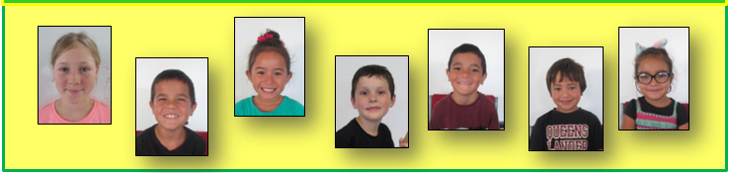
Dear parents, whanau and community members,

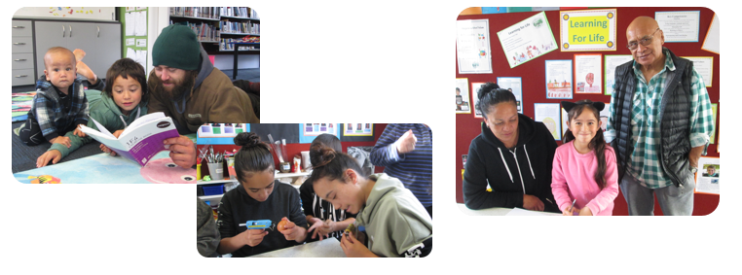
Thank-you to all those who came along on Whanau Day. The children are always eager to share what they have done with you. It was great that all had at least one family member present.

The children have well and truly settled back into school routines after the holidays.
Our main focus for the term is health and well-being – Hauora. This covers 4 separate areas –
- Physical – healthy bodies through exercise, good diets
- Mental – personal identity
- Whanau – relationships with family and friends
- Spiritual – demonstrating values, being the best sort of person you can be
Much of our reading and writing will be related to this topic, then later in the term all will write speeches. The old (dreaded) fractions will be studied in maths, along with time and measurement. Coming up will be cross country at Whangaehu School, so the children have been out training each day.

After reading a book rich in vocab about a ‘scowly, growly, grouchy grump’ the children wrote about
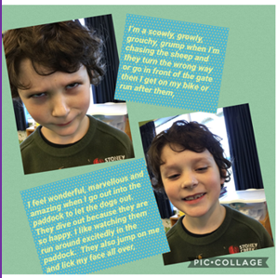
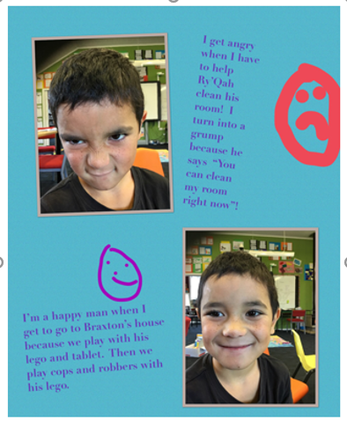
their own experiences of being grumpy and happy. These were published on the iPads, with photos added.

Recently we have been leaning about language features in writing –
- Personification – where things are given human qualities and characteristics
- Onomatopoeia – words sounding like they are spelt such as BANG! And BOOM!
- Similes – where something is compared to another thing e.g. He was as sly as a fox.
The children were tasked with using all of these in a short poem.
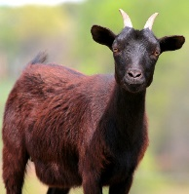

Dad and papa and I went hunting
for goats,
We saw a brown goat that looked
like a boar,
BANG! Went the gun,
He turned around, gave us the evil eye, spat at us and sped back to the bush,
BAAAA!

By Hozai

Once upon a time I saw a stoat racing across a road,
He was as fast as a rabbit and hid in the long, green grass,
Dancing and playing, trying to trick the bunny,
Next minute BOOM!!!! He grabbed the rabbit,
And he ran away back home to gobble up his lunch.

By Chardel

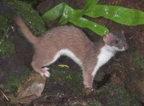
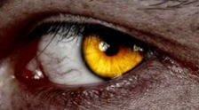

Student of the Week

Term 2 Week 9  Emily  Showing increased perseverance on all areas | Term 3 Week 1  Hozai Te Puni-Olsen  Increased effort, resulting in great writing

Upcoming Events

Dental Visit – The dental nurses are coming for check-ups this Wednesday, 31st July. They would like preschoolers to come at 9am please.
Board of Trustees News
Next Meeting – Monday 5th August at 4:30pm. All welcome to attend.

Kakatahi School visits – we are going to them on Wednesday 7th August, then they come to us on Wednesday 11th September.

Cross Country – Friday 6th September (with the following Friday as back up day) at Whangaehu School.

Pet Day – Just to give you the heads up, we will be having pets at Pet Day again this year. It is planned for the first Friday in term 4. More details will be given closer to the event.

125th School Anniverary – This is fast approaching on Saturday 26th October. An invitation has been sent to the community, so if you plan on coming along, please RSVP so that we know numbers.

Term 3
Town each Thursday for swimming and tikanga.
Week 3 | Monday 5th August | Board Meeting at 4.30pm
 | Wednesday 7th August | Visit to Kakatahi School
Week 7 | Friday 6th September | Cross Country
Week 8 | Monday 9th September | Board Meeting at 4.30pm
 | Wednesday 11th September | Visit by Kakatahi School
 | Friday 13th September | Cross Country postponement day
Dates to remember – 2019

Rosalie Matthews
Principal

