MANGAMAHU SCHOOL
Respect Excellence Responsibility Resourcefulness
Newsletter No 8 11th September 2017

Dear parents, whanau and community members,

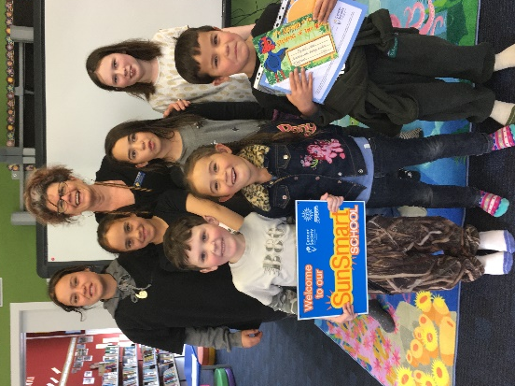
Congratulations to June Crothers; she has published her second children’s book Minute Mayhem. She kindly donated a copy to the school for our children to enjoy. Thank-you.

Sun Smart – Our school is now accredited as a Sun Smart School as we follow good sun smart procedures. One of their representatives came to school recently to present us with a plaque, certificate and sunscreen.

Upcoming events
Student Led Conferences – these are set for Wednesday 20th September. A notice will be sent home soon to set times. If that day does not suit you, just let us know, and we will find another time.

Cluster Speech Contest – to be held at Kaitoke School on Thursday 21st September at5.30pm. We will have one representative from Year 5/6 and one from Year 7/8. Parents to transport their own children, and are asked to bring a plate to share. We will let you know soon who has been chosen.
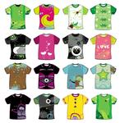
Loud Shirt Day / Open Day – The last day of this term, Friday 29th September, will be a fund-raiser for hearing impaired children. All to wear bright, bright clothes; please donate a gold coin. This will also be Open Day, so parents are invited to pop in anytime of the day to look at the work the children have done. The students can also show you how we use technology. Feel free to come brightly dressed – you’ll fit right in!

Kapa Haka – I have spoken to Okoia School and they are happy for us to join in with their programme, so we will begin in term 4. It will be on Thursday afternoons, and sessions run from 1.15pm to 2.30pm. We will leave school at 12.30pm and return by approximately 3.10pm.
Student Awards
Ry’Qah Mea – focusing well in maths
Jilyzah Tonihi – great effort at gymnastics
and swimming

Pet Day – set for Friday 3rd November
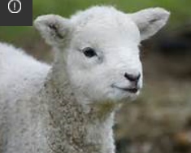

Spring
Cute calves drinking milk from their mums
Green grass growing because it is a sunny day
Fluffy lambs drinking milk noisily
Little chicks sleeping in their nest
Yellow honey bees collecting honey from the blossoms
Chardel
Spring
White eggs staying warm in the nest
Pretty flowers growing in the grass
Black calves jumping like wild cows
White lambs running across the paddock like crazy.
Braxton
Spring Time

Spring
Yellow ducklings waddling in a line
White lambs jumping and leaping in the paddock
Ginger calves drinking milk from their mums
White cockatoos hatching out of cracked eggs
Ry’Qah

Board of Trustees News
Next Meeting – Monday 6th November at 6pm.
All welcome to attend.

Dates to remember

Every Monday from 10am to about 11.30am – Playgroup.
Everyone welcome to attend. Come along for a coffee and a chat even if you don’t have a preschooler.

 | Term 3 2017
Week 9 | Wednesday 20th September | Student Led Conferences
 | Thursday 21st September | Speech Contest at Kaitoke School
 | Friday 22nd September | Assembly at 2.20pm
Week 10 | Friday 29th September | Loud Shirt Day / Open Day  Last day of term 3
Term 4 2017
Kapa Haka each Thursday at Okoia School
Week 1 | Monday 16th October | First day Term 4
Week 3 | Friday 3rd November | Pet Day
Week 4 | Monday 6th November | BOT meeting at 6pm
Rosalie Matthews
Principal

