MANGAMAHU SCHOOL
Respect Honesty Empathy Responsibility Perseverance
Newsletter No 5 31st July 2018

ear parents, whanau and community members,

Dear parents, whanau and community members,
Sadly our Board Chairperson Vanessa Williams passed away recently. She bravely fought a long battle with cancer and remained remarkably positive until the very end. Vanessa will be sadly missed by all, and our thoughts go to her family, and particularly to Blair, Brooklynne and Braxton.

Open Day – Thank-you to everyone who came along. Not only did we have parents from all families, but there were grandparents from most as well.
The students ran the day and involved the adults in art, netball, a game of Kahoot, as well as sharing their work.
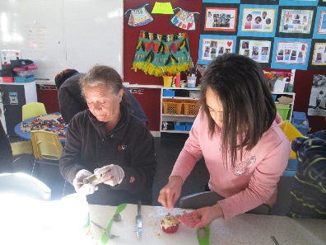
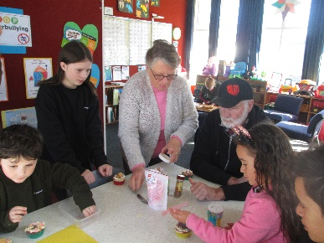
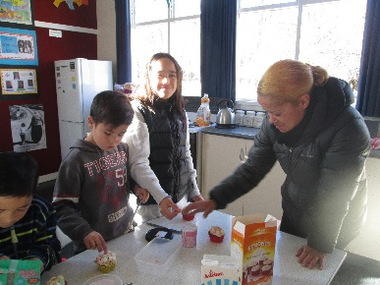
Open Day
On Open Day lots of whanau came. We had the Budges, the Tonihis and the Sutton-Meas. There were more visitors than kids!
After showing them our work in our books, on the tablets and on the walls, we had a cupcake competition. Nanny Donna won because hers looked like a cactus. L’Bron then ran a netball shooting competition. Nate got mixed up and played it like it was basketball. L’Bron won!
Brooklynne was then in charge and got everyone to do an art activity. It was making funny faces out of clay. Ry’Qah added too much water and his face mooshed up on the table, and everyone got sticky, slimy hands.
After cleaning up we all played some games of Kahoot on the tablets. The Budges won both of them. We then shared a barbecue lunch outside.
The day was awesome because all our whanau came (and we didn’t have to do any work! – from Ry’Qah).
Shared writing by Chardel, Ry’Qah and L’Che

Proposed Stop Work – As you may know from the media there is a proposed stop work for schools set for Wednesday 15th August. As negotiations are ongoing with the government the stop work is not definite yet, and we don’t know if it is for a full or half day. I just wanted everyone to be warned that it may happen, and if it does the school will be closed.
The main issues that affects our school are –
- teacher shortages (we had no applicants for our part-time job advertised earlier this year)
- additional staffing in small schools so sole charge principals are not alone for health and safety reasons
As soon as I know more I will let you know.

Student Awards
Jilyzah Tonihi – for responsibility and helpfulness
Braxton Budge – great progress in reading

Board of Trustees News

Next Meeting –
Monday 13th August at 4:30pm.
All welcome to attend.

Dates to remember – Term 3 2018
Every Monday from 10am to about 11.30am – Playgroup.
Everyone welcome to attend. Come along for a coffee and a chat even if you don’t have a preschooler.

Term 3 2018
Thursday every week – Technology, swimming & dance
Week 3 | Friday 10th August | Assembly at 2.30pm
Week 4 | Monday 13th August | BOT meeting at 4.30pm
Week 6 | Tuesday 28th August | Duffy Books Play at Okoia School
 | Friday 31st August | Assembly at 2.30pm
Rosalie Matthews- Principal
Tiffiney Firmin – Office Admin & Teacher Aide

